Gage Golf  2026 Tournements & Events | 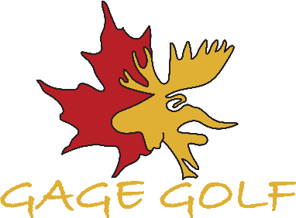
Event | Date
Legion Tournament | 6 June @ 1pm shotgun
5 CDSG Golf to Give | 12 June All day times
GAGE 2 Person Scramble | 28 June @ 8 am Shotgun
OPH- Hospital Foundation 4 Person Scramble | 4 July @ 1pm Shotgun
Senior Men’s Invitational | 9 July tee times
Oromocto Firefighters Charity Golf | 11 July @ 1pm Shotgun
Gage Triple 6 | 19 July @ 8am shotgun
Leah Sabourin Ladies Invitational | 19 July @ 1:30pm shotgun
Junior Golf League Invitational | 23 July tee times
Tim Bennett Memorial | 8 Aug @1pm Shotgun
2025 Club Championship | 15 & 16 Aug all day
SOLDIER ON Tournament | 20 Aug all day tee times
14th Annual John Wood Charity | 22 Aug @ 1pm Shotgun
GAGE Mixed Tournament | 23 Aug @ 8am Shotgun
RCLS Golf Tournament - Logistics | 28 Aug @ 1:00 am Shotgun
John Fife Memorial (Trio) | 12 & 13 Sept all day
Frank Dunn Annual New Maryland Tournament | 19 Sept @ 1:00 Shotgun
3rd Annual Andy Mitton Memorial | 27 Sept @ 1pm Shotgun
EME Golf Tournament | 25 Sept @ 8am Shotgun
2nd Annual Ben Noseworthy Tournament | 3 Oct @ 1:00 pm Shotgun
Battle of the Gage | 25 Oct all day
www.gagegolfandcurling.com

